**ECE2021 Smart Building Project Proposal**

----------------------------------------------------------------------------------------------------------------------------

**Mini Smart House**

**Group Members:**

Lê Quốc Định - 10221009

Phạm Nam Nhật - 10221036

Trần Hồng Vũ - 10221049

**WINTER SEMESTER 2023**

**INDEX**

1. **Introduction**

1.1. Problem Background 2

1.2. Objective 2

1.3. Requirements and Specifications 3

1. **Statement of work**

2.1. System Description 8

2.2. Design Approach 10

2.3. Method of Solution 12

2.4. Project Timeline 13

2.5. Division of Labor 13

2.6. Ethical Dimensions and Safety Aspects 14

1. **Conclusion**

3.1. Key Points 15

3.2. Advantages 15

3.3. Summary 15

**1. Introduction**

**1.1. Problem Background**

The idea of traditional locks and keys has changed significantly in an era marked by fast

technological developments. Smart locks, often known as electronic locks, are a

cutting-edge way to improve convenience and security in residential settings. Without the

need of actual keys, these electrical locks use electronic identification techniques to grant

entry to the premises. Modern electronic locks are equipped with a plethora of advanced

functions, such as Bluetooth or Wi-Fi networking, password authentication, fingerprint

recognition, and remote control.

Moreover, we investigate the integration of motion sensors for the purpose of

automatically turning on lights in the hallway. This effectively addresses a critical

security concern by removing regions that may be dangerous or dark. Homeowners may

accomplish a comprehensive approach to domestic security that strikes a balance between

convenience and safety by integrating these cutting-edge technologies.

Today with climate change, the temperature rose significantly, installing auto cooling systems by using fans and humidity sensors to keep the house in a flexible environment for homeowners’ health and comfortable feeling.

**1.2. Objective**

In this project, we use a capacitive fingerprint sensor instead of an optical sensor for

security purposes. This will be installed on the door and connected to a circuit board in

the hallway. The motion sensor we use will be a PIR sensor because of its high accuracy

and affordable cost. Also, a temperature and an LCD to show room temperature will be

installed inside.

**1.3. Requirements and Specifications**

| PART | PRICE/UNIT | QUANTITY | TOTAL PRICE |
| --- | --- | --- | --- |
| Arduino UNO R3 V3 | 155.000VND | 2 | 310.000VND |
| Jumper Wire (40) | 28.000VND | 2 | 56.000VND |
| Electric Lock | 120.000VND | 1 | 120.000VND |
| Relay Opto (5V) | 20.000VND | 4 | 80.000VND |
| 12V DC Adapter | 40.000VND | 1 | 40.000VND |
| Bucking circuit (5V -> 3.3V) | 6.000VND | 2 | 12.000VND |
| Bucking circuit (12V -> 5V) | 30.000VND | 1 | 30.000VND |
| ESP32 WROOM | 215.000VND | 1 | 215.000VND |
| R503 Capacitor Fingerprint Sensor | 413.000VND | 1 | 413.000VND |
| Push button | 6.000VND | 4 | 24.000VND |
| Buzzer circuit | 10.000VND | 1 | 10.000VND |
| Digital PIR motion  Sensor | 103.000VND | 1 | 103.000VND |
| Light Bulb (~220V) | 80.000VND | 1 | 80.000VND |
| Hinge and jack | 25.000VND | 1 | 25.000VND |
| Led RGB 5MM Katot Chung | 3.500VND | 3 | 10.000VND |
| 5V Fan (small) | 40.000VND | 1 | 40.000VND |
| Boost Converter Circuit (3.3V -> 5V) | 20.000VND | 1 | 20.000VND |
| BreadBoard MB-102 **830** holes | 25.000VND | 2 | 50.000VND |
| BreadBoard MB-102 **400** holes | 16.000VND | 1 | 16.000VND |
| DHT22 Temperature Humidity Sensor | 107.000VND | 1 | 107.000VND |
| Screen Text LCD1602 (green) | 28.000VND | 1 | 28.000VND |
| LCD1602 to I2C Interface Converter Circuit | 16.000VND | 1 | 16.000VND |
| 5V Fan (big) | 65.000VND | 1 | 65.000VND |
| Resistor (330 and 1k ohm) | 10.000VND | 1 | 10.000VND |
| Fomex and craft | 220.000VND | 1 | 220.000VND |
| Another | 100.000VND | 1 | 100.000VND |
| Total | | 2.200.000VND | |

*Power supply:*

In order to maintain the operation of the machine and its associated hardware peripherals,

the presence of a power source is essential.

*Arduino Uno R3 V3:*

The Arduino Uno R3 V3 is a popular open-source microcontroller board, known for

its versatility and ease of use. It is based on the ATmega328P microcontroller

and features a wide range of digital and analog input/output pins, making it suitable

for various electronics projects.

| **Parameter** | **Value/Range** |
| --- | --- |
| Microcontroller | ATmega328P |
| Operating Voltage | 5V |
| Input Voltage (recommended) | 7-12V |
| Digital I/O Pins | 14 (of which 6 can be used as PWM outputs) |
| Analog Input Pins | 6 |
| DC Current per I/O Pin | 20 mA |
| DC Current for 3.3V Pin | 50 mA |
| Flash Memory | 32 KB (of which 0.5 KB is used by the bootloader) |
| SRAM | 2 KB |
| Clock Speed | 16 MHz |

*Electric Lock:*

Electric lock powered by a 12VDC source.

| **Parameter** | **Value/Range** |
| --- | --- |
| Operation Voltage | 12 VDC |
| Current Consumption | 0.8A |
| Reaction Speed | < 1s |

*Buzzer:*

A buzzer is intended to signal users when their access is denied, with this notification

being conveyed through a digital signal from the microcontroller.

| **Parameter** | **Value/Range** |
| --- | --- |
| Operating Voltage | 3.3 ~ 5VDC |
| Operating Current | 20mA |
| Sound Amplitude | up to 100dB. |
| Signal | PWM |
| Trigger Signal | LOW-Edge-Trigger |

*Button:*

A small low-cost button to activate a part of the circuit.

*Relay Module:*

A relay functions as an electrically operated switch designed for the control of devices

and systems that operate with higher voltage levels. The primary function of a relay

module is to toggle the power supply of electrical devices and systems, facilitating their

activation or deactivation.

| **Parameter** | **Value/Range** |
| --- | --- |
| Voltage | 5VDC |
| Current | 200mA |
| Signal | HIGH(5V-DC)/ LOW(0V-DC) |
| Safety Close at | 250VAC-10A / 30VDC - 10A |

*PIR Sensor:*

PIR (Passive Infrared) motion sensors are pivotal devices in the realm of electronics and

security systems. These sensors are designed to detect changes in thermal radiation

within their field of view, making them exceptionally adept at detecting human and

animal motion.

| **Parameter** | **Value/Range** |
| --- | --- |
| Voltage range | 3V–5V |
| Detecting angle | 100 degree |
| Detecting distance | 3.2m-12m |
| Response time | < 1s |

*Fingerprint Sensor:*

Capacitive fingerprint sensors work by placing a series of capacitors under the surface of

the sensor. When a finger is placed on the sensor, the ridges and valleys on the fingerprint

create a slight difference in capacitance between the capacitors. This difference in

capacitance is measured by the sensor and used to create an image of the fingerprint.

| **Parameter** | **Value/Range** |
| --- | --- |
| Type | Capacitive fingerprint |
| Operating Voltage | 3.3VDC |
| Operating Current | 20mA |
| Resolution | 508 DPI |
| False Accept Rate (FAR) | <0.001% |
| False Reject Rate (FRR) | <1.0% |
| Interface | UART (TTL) serial |
| Storage Capacity | 200 fingerprints |
| Scanning Speed | < 0.2s |
| Verification peed | < 0.3s |

*ESP32 Module:*

As a powerful microcontroller, the ESP32 offers a unique blend of Wi-Fi and Bluetooth

connectivity, making it an ideal choice for this context.

| **Parameter** | **Value/Range** |
| --- | --- |
| Type | System on a chip (SoC) |
| Wi-Fi | 802.11 b/g/n @ 2.4 GHz |
| Bluetooth | Bluetooth V4.2 BR/EDR & Bluetooth LE specification |
| Flash Memory | 4 MB |
| SRAM | 520 KB |
| Operating Voltage | 3.3 V |

*Humidity Sensor:*

Humidity sensors, also known as hygrometers, are electronic devices that measure the

amount of moisture in the air. They are commonly used in a variety of applications,

including weather stations, HVAC systems, and industrial processes.

| **Parameter** | **Value/Range** | |
| --- | --- | --- |
| Power supply | 3~5VDC | |
| Current consumption | 2.5mA max (during data transmission) | |
| Humidity range | 0-100%RH | |
| Humidity accuracy | 2-5% | |
| Temperature range | -40 to 80°C | |
| Temperature accuracy | ±0.5°C | |
| Maximum sampling rate | 0.5Hz (once every 2 seconds) | |
| Number of pins | 4 | |
| Pin spacing | 0.1'' | |

*LCD:*

A type of flat-panel display that is commonly used in televisions, computers,

smartphones, and other electronic devices. LCD screens are known for their high image

quality, low power consumption, and wide viewing angles.

| **Parameter** | **Value/Range** |
| --- | --- |
| Operating Voltage | 5V |
| Dimensions | 80 x 36 x 12.5 mm |
| Display Color | Black characters on a green background |
| Pin Spacing | 0.1 inch (convenient for Breadboard connections) |
| Pin Names | Printed on the back of the LCD screen for easy wiring |
| Backlight | LED backlight, can be controlled with a variable resistor or PWM for power-saving brightness adjustment |
|
| Signal Control | Can be controlled with 6 signal wires |
| I2C Model Support Communication  LCD1602 | Vcc = 5V-DC, GND, SDA, SCL |

*Fan and LED:*

Low-cost fan and LED.

*See our materials’ datasheets on Google Sheets for more details:* [Materials' DTS](https://docs.google.com/spreadsheets/d/1kIMBDzdMBAZG7Pc1pW9EjhvXKuDuX7hplWPtkL5cv-g/edit?usp=sharing)

**2. Statement of work**

**2.1. System Description**

Our project will have an Arduino UNO on the backside of the door attached to a board of

an electric lock, a small button, a relay module, an ESP32 module. These will be attached

to a PIR sensor and LEDs on the ceiling. Another Arduino UNO will be used for

connecting to a humidity sensor which will detect room temperature and be shown on a

LCD screen, then adjust the room temperature by turning a fan on a wall. The frontside of

the door will have a fingerprint authenticator and a buzzer, which will be wired through

the door.

Below is a block diagram of our project:

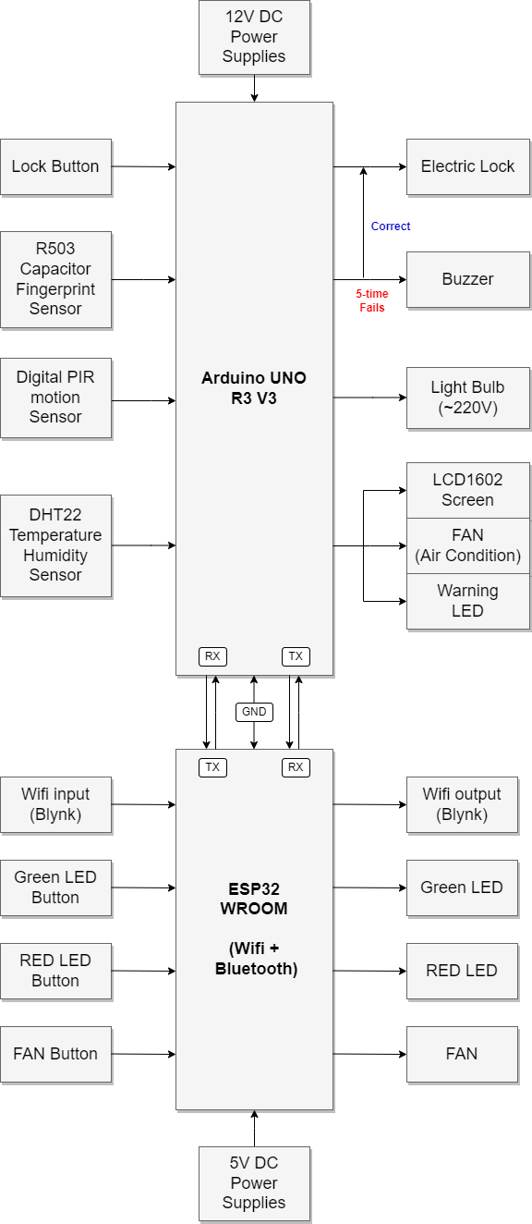

**2.2. Design Approach**

This system will put a lot of pressure on an Arduino, that’s why we use 2 instead of 1. 1

will be used for controlling the PIR sensor and the fingerprint scanner and locker, the

other will be used to control the humidity sensor and the LCD screen. The power supply

We will use 220V so we will need the relay module in nearly every part of the circuit.

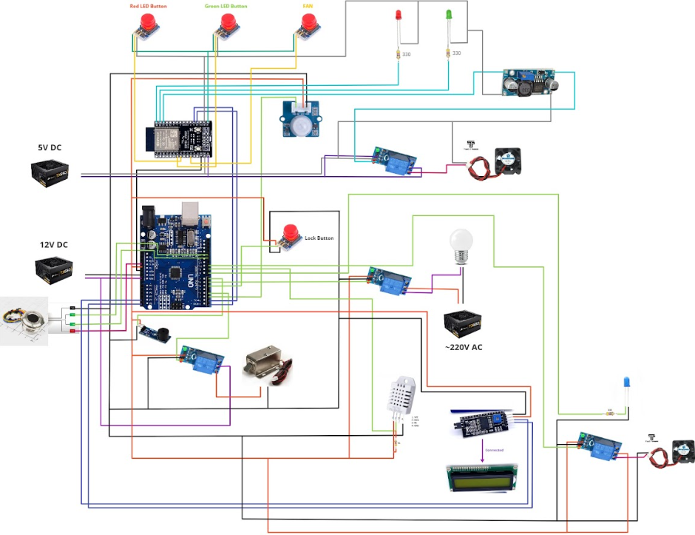

***Circuit Design***

Circuit designing is a very important skill to maintain a current inside the circuit and to

not break electrical devices. The system will be programmed in Python on Arduino IDE

2.0.2. A smartphone application will be Blynk to develop Wi-Fi communication.

*See our circuit design on website for more details:* [Circuit Design](https://miro.com/app/board/uXjVNXGbjN0=/)

Below is our wiring tables:

| **Arduino UNO R3 V3** | | | |
| --- | --- | --- | --- |
| **Pin Name** | **Pin Number** | **Input/Output** | **Description** |
| RX (<-) | 0 | Digital I/O (Input) | UART Communication with TX of ESP32 |
| TX (->) | 1 | Digital I/O (Output) | UART Communication with RX of ESP32 |
| D2 | 2 | Digital I/O (Input) | Grove-Digital PIR Motion Sensor |
| D3 | 3 | Digital I/O (Output) | Relay_Electric_Lock |
| D5 | 5 | Digital I/O (Input) | Push Button |
| D6 | 6 | Digital I/O (Output) | Relay_Light_Bulb |
| D7 | 7 | Digital I/O (Output) | Buzzer |
| D8 | 8 | Digital I/O (Output) | LED_Warning |
| D9 | 9 | Digital I/O (Input) | DHT22 Sensor Data Pin |
| D10 | 10 | Digital I/O (Output) | Relay_Motor_Fan |
| D12 | 12 | Digital I/O (Input) | R503 Fingerprint Sensor Data Pin |
| D13 | 13 | Digital I/O (Input) |
| A4 | A4 | Analog I/O (Output) | I2C Model Support Communication  LCD1602 - (SDA) |
| A5 | A5 | Analog I/O (Output) | I2C Model Support Communication  LCD1602 - (SCL) |
| 5V | 5V | Output | Power supply for the Grove-Digital PIR Motion Sensor, Push Button, LED, 3 Relays, Buzzer, DHT22 Sensor |
| GND | GND | Ground | Ground for the Grove-PIR Motion Sensor, R503 Fingerprint Sensor, Push Button, LED, Buzzer, 3 Relays, DHT22 Sensor, I2C Model Support Communication LCD1602 and ESP32 Module |

| **ESP32 WROOM** | | |
| --- | --- | --- |
| **Pin Number** | **Input/Output** | **Description** |
| RX (<-) | Digital I/O (Input) | UART Communication with TX of Arduino UNO |
| TX (->) | Digital I/O (Output) | UART Communication with RX of Arduino UNO |
| 14 | Digital I/O (Output) | Relay_Fan |
| 15 | Digital I/O (Output) | LED 2 |
| 16 | Digital I/O (Output) | LED 1 |
| 25 | Digital I/O (Output) | Push Button 2 |
| 26 | Digital I/O (Output) | Push Button 1 |
| 33 | Digital I/O (Output) | Push Button 3 |
| BLynk | Wifi  Input-Output | BLynk Cloud App (IoT) |
| 3.3V | Output | 2 LEDs, Relay, 3 Push Buttons |

**2.3. Method of Solution**

The main circuit will be installed on the wall near the door to optimize the wiring

distance between every part. The sensor will be wired through the door and placed on the

outside of the door. When homeowners put their assigned finger on the sensor, the sensor

will send a signal to the Arduino on the circuit and activate the locker inside the door.

This will leave on for 90 seconds and then lock the door again. If a thief is trying to

fake a fingerprint, the counter will be activated and after 3 times wrong counts, the

buzzer will be on its work.

After homeowners enter their home, the PIR sensor on the ceiling will detect the presence

of them and send a signal to activate lights in the hallway to help homeowners make

through the hallways. The temperature in the house is already and will always be

adjusted by the fan if the humidity sensor finds the room is not in its appropriate scale.

The locker, the lights, the buzzer, and the fan can be activated through the Blynk app on

the smartphone which has already been assigned a homeowner's token, which is exclusive. Also, we installed several buttons for testing inside the house and to deactivate the locker if homeowners want to leave.

**2.4. Project Timeline**

In the first 3 weeks of November mostly we used it for testing and developed

communication between Arduinos and every part of the project. After that, we

apply every part into one and maintain its communication and also its current.

In the final stages, we adjust the wiring and build the house model which is based on

our dorm’s room.

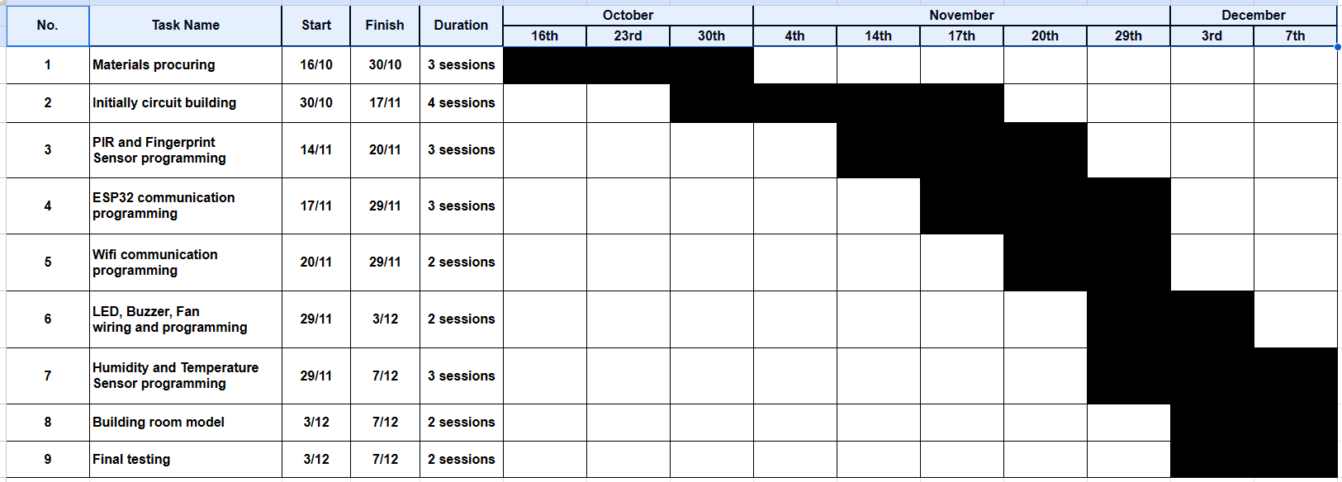

*For more details, access* [Timeline](https://docs.google.com/spreadsheets/d/1OscG6F4ajm2IURTPvoqTMXeiAcVic2-i6L9XRQJJkjg/edit?usp=drive_link).

**2.5. Division of Labor**

| Circuit Wiring | Le Quoc Dinh, Pham Nam Nhat |
| --- | --- |
| Programming | Le Quoc Dinh, Tran Hong Vu |
| Model Building | Pham Nam Nhat, Tran Hong Vu |

**2.6. Ethical Dimensions and Safety Aspects**

**2.6.1. Ethical Dimensions**

*Privacy Concerns:*

The collection and storage of data for fingerprint authentication raise critical privacy

concerns. Users must entrust their most unique and personal identifiers to these systems,

invoking questions about data security and the potential for misuse.

*Informed Consent:*

Ethical best practices dictate that users should be fully informed about how their data is

used, stored, and protected. Ensuring informed consent is essential to maintaining the

ethical integrity of these systems.

*Cultural Considerations:*

Different cultures have varying attitudes towards biometric data and surveillance. Ethical

discussions must encompass cultural diversity and sensitivities, ensuring that these

technologies are adopted in ways that respect cultural norms.

**2.6.2. Safety Aspects**

*Security Enhancements:*

Smart door locks with fingerprint authentication undoubtedly enhance security by

providing a highly reliable means of access control. The unique nature of fingerprints

minimizes the risk of unauthorized entry.

*Motion-Sensor-Activated Lighting:*

The integration of motion-sensor-activated lighting contributes not only to security but

also to safety within the home. Illuminated pathways reduce the risk of accidents and

provide a sense of security during the dark hours.

*Auto-Cooling Method:*

The method helps keeping the temperature in appropriate scales to provide a flexible

and comfortable environment.

*Emergency Response:*

The ability of these systems to respond to unexpected events, such as break-ins or

accidents, can significantly enhance safety. This capability requires a robust design to

effectively address emergency situations.

**3. Conclusion:**

**3.1. Key Points**

This project is used to provide a mini smart house model with a fingerprint locker,

lightning hallway and auto-cooling system.

**3.2. Advantages**

This system reduces people’s concerns about security and their house’s environment day

by day. The system is low cost so it would be affordable for everyone.

**3.3. Summary**